

Development of observatories

Astronomy



February 22, 2021

progress school

Mohammadreza Badpa

# Introduction

Astronomical observatory, any structure containing telescopes and auxiliary instruments with which to observe celestial objects. Observatories can be classified on the basis of the part of the electromagnetic spectrum in which they are designed to observe. The largest number of observatories are optical; i.e., they are equipped to observe in and near the region of the spectrum visible to the human eye. Some other observatories are instrumented to detect cosmic emitters of radio waves, while still others called satellite observatories are Earth satellites that carry special telescopes and detectors to study celestial sources of such forms of high-energy radiation as gamma rays and X-rays from high above the atmosphere.

# History

## Introduction

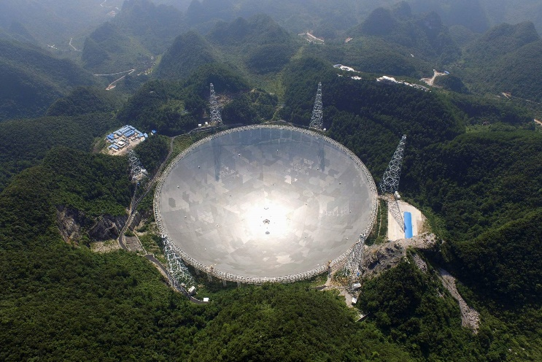Optical observatories have a long history. The predecessors of astronomical observatories were monolithic structures that tracked the positions of the Sun, Moon, and other celestial bodies for timekeeping or calendrical purposes. The most famous of these ancient structures is Stonehenge, constructed in England over the period from 3000 to 1520 BCE. At about the same time, astrologer-priests in Babylonia observed the motions of the Sun, Moon, and planets from atop their terraced towers known as ziggurats. No astronomical instruments appear to have been used. The Maya people of the Yucatán Peninsula in Mexico carried out the same practice at El Caracole, a dome-shaped structure somewhat resembling a modern optical observatory. There is again no evidence of any scientific instrumentation, even of a rudimentary nature.

## Hipparchus

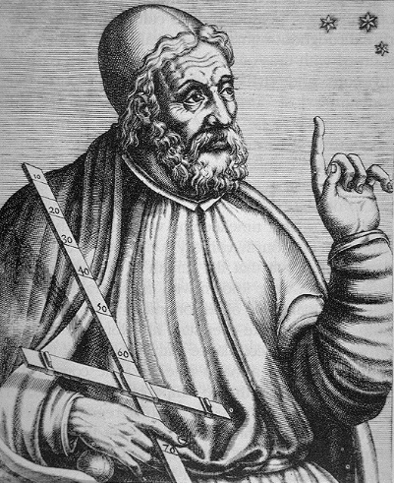Perhaps the first observatory that used instruments for accurately measuring the positions of celestial objects was built about 150 BCE on the island of Rhodes by the greatest of the pre-Christian astronomers, Hipparchus. There he discovered precession and developed the magnitude system used to indicate the brightness of celestial objects. The true predecessors of the modern observatory were those established in the Islamic world.

## Islamic World

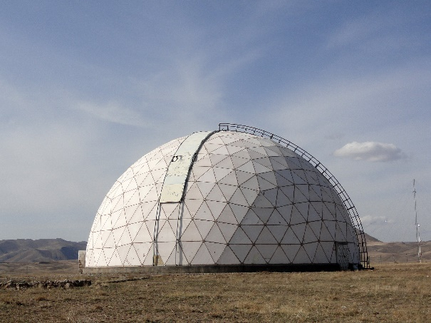Observatories were built at Damascus and Baghdad as early as the 9th–10th century CE. A splendid one was built at Marāgheh (now in Iran) about 1260 CE, and substantial modifications in Ptolemaic astronomy were introduced there. The most productive Islamic observatory was that erected by the Timurid prince Ulūgh Beg at Samarkand about 1420; he and his assistants made a catalog of stars from observations with a large quadrant.

## Galileo Galilei

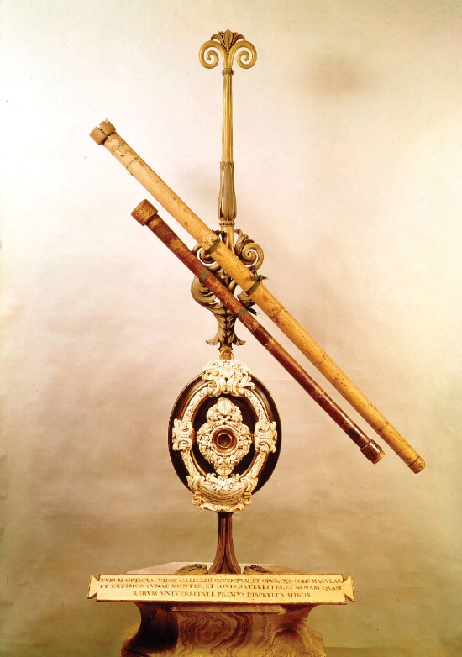The first optical telescope used to study the heavens was constructed in 1609 by Galileo Galilei, using information from Flemish pioneers in lens-making. Such centers were founded in the 18th and 19th centuries at Greenwich (London), Paris, Cape Town, and Washington, D.C. By timing the passage of stars as the local meridian was swept past them by Earth’s rotation, astronomers were able to improve the accuracy of position measurements of celestial objects from a few minutes of arc (before the advent of the telescope) to less than a tenth of a second of arc.

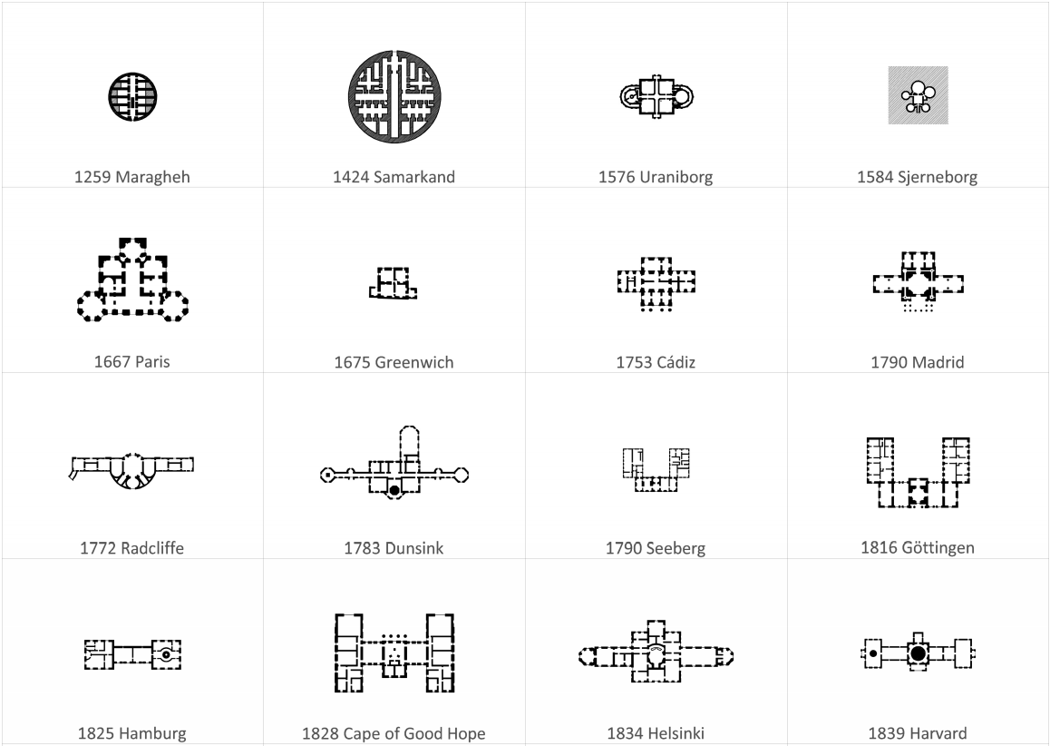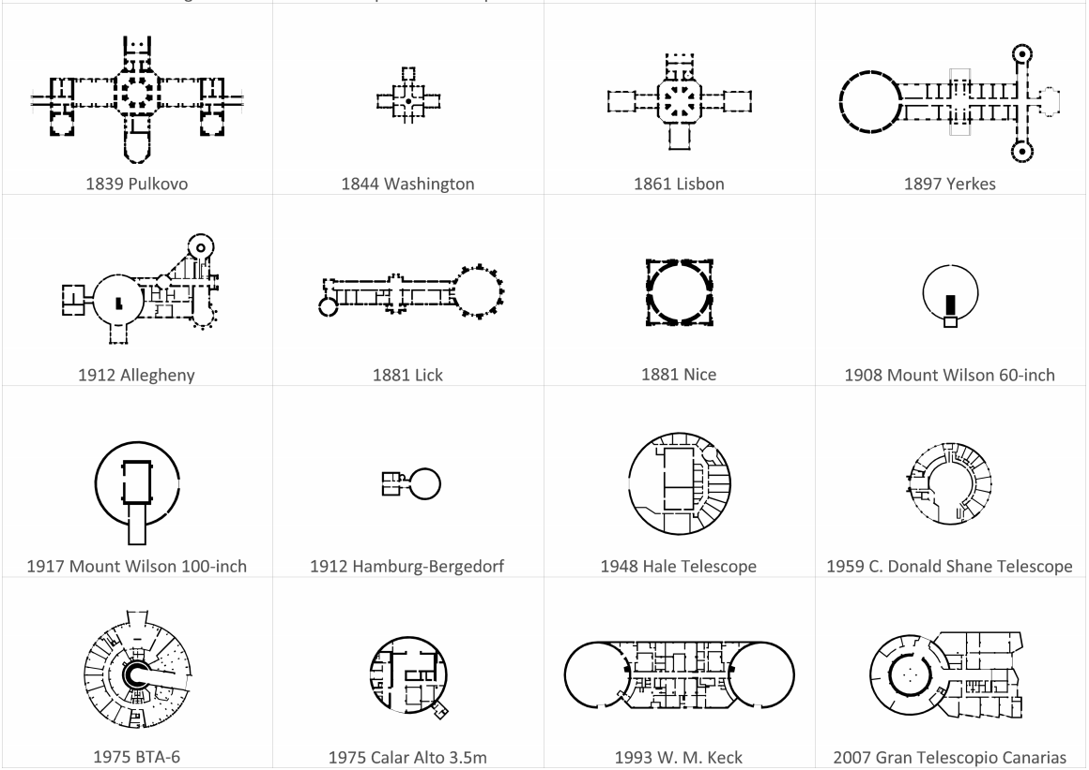

## References

An Article Published under Creative Commons license CC BY-SA 4.0 By the Journal of the Korean Astronomical Society

The evolution of Astronomical Observatory design: researchgate.net/publication/337532142_The_evolution_of_Astronomical_Observatory_design

Article in britannica.com/topic/Jodrell-Bank-Observatory